Project Design Phase-II
Technology Stack (Architecture & Stack)

Date | 2 October 2026
Team ID | SWTID-2026-6670
Project Name | Implement Client Script & UI Policy (Incident)
Maximum Marks | 4 Marks

Technical Architecture:
The Deliverable shall include the architectural diagram as below and the information as per the table1 & table 2
Example: Client-side data validation for Incident records in ServiceNow
Architecture flow (numbers match the diagram):
1. The Service Desk Agent opens the Incident form or list view in a browser.
2. Impact and other field events are evaluated by the UI Policy "High Impact Control".
3. The UI Policy result and field changes reach the Client Scripts (onChange, onSubmit, onCellEdit).
4. A validated record is passed on to the Incident table.
5. The record is stored in the cloud-hosted instance database.
6. The Administrator configures UI Policies and Client Scripts through System UI.
7. The configuration is loaded by the Incident form at runtime.
Technical architecture diagram
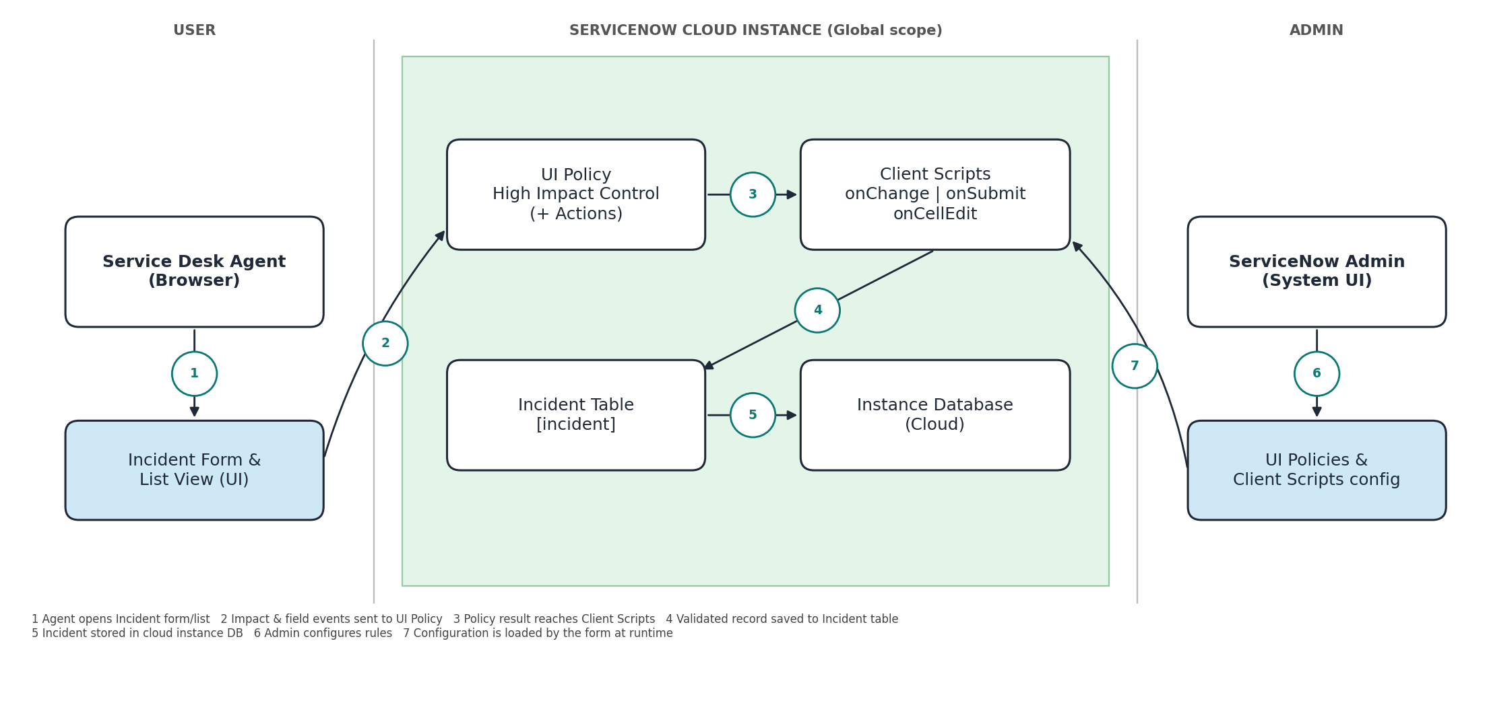
Table-1 : Components & Technologies:
S.No | Component | Description | Technology
1. | User Interface | How the user interacts with the application: the ServiceNow Incident form and Incident list view in a web browser. | ServiceNow platform UI (HTML, CSS, JavaScript) in Chrome / Edge
2. | Application Logic-1 | UI Policy "High Impact Control" on the Incident table. When Impact = 1 - High it makes Assignment group mandatory; Reverse if false is enabled. | ServiceNow UI Policy (System UI > UI Policies)
3. | Application Logic-2 | UI Policy Action on Urgency (Read-only = true, Visible = Leave alone) and onChange Client Script "Auto set urgency for high impact" on the Impact field. | UI Policy Action; Client Script (onChange), g_form API, JavaScript
4. | Application Logic-3 | onSubmit Client Script "Prevent save if Assigned To missing" blocks save and shows an error when Impact is High and Assigned To is empty. | Client Script (onSubmit), g_form.getValue / showErrorBox, JavaScript
5. | Application Logic-4 | onCellEdit Client Script "Prevent state change via list edit" stops State being edited directly from the list and shows an alert. | Client Script (onCellEdit), JavaScript
6. | Database | Incident records are stored in the Incident [incident] table (extends Task). Fields used: Impact, Urgency, Assignment group, Assigned to, State. | ServiceNow platform relational database
7. | Cloud Database | Database service is hosted with the cloud-hosted ServiceNow instance (developer instance dev354432). No separate database is set up. | ServiceNow cloud instance
8. | File Storage | No file storage requirement. Configuration can be moved between instances with Update Sets if needed. | Not applicable (ServiceNow Attachments / Update Sets available)
9. | External API-1 | No external API is used in this project. | Not applicable
10. | External API-2 | No second external API is used. | Not applicable
11. | Machine Learning Model | No machine learning model is used. All behaviour is rule-based. | Not applicable
12. | Infrastructure (Server / Cloud) | Application deployed on a cloud-hosted ServiceNow instance, accessed from the browser.  Local Server Configuration: none, a modern web browser is enough.  Cloud Server Configuration: ServiceNow developer instance, Global application scope, admin access. | ServiceNow cloud (SaaS / PaaS)
Table-2: Application Characteristics:
S.No | Characteristics | Description | Technology
1. | Open-Source Frameworks | No third-party open-source framework is needed. Scripts use plain JavaScript with the ServiceNow client-side API. | JavaScript (ES5, isolate script enabled)
2. | Security Implementations | Configuration changes need admin role. Access follows role-based ACLs. Scripts run isolated with no direct DOM access, and traffic uses HTTPS. Note: client scripts can be bypassed through APIs, so a server-side Business Rule is a recommended later addition. | Role-based access control, ACLs, HTTPS/TLS, Isolate script
3. | Scalable Architecture | Runs on the ServiceNow multi-tenant cloud platform. Validation executes in the user's browser, so it adds almost no server load as the number of users grows. | ServiceNow platform (3-tier: browser, application, database)
4. | Availability | Availability comes from the ServiceNow hosting service (redundant data centres, managed by the vendor). Personal developer instances may hibernate when idle. | ServiceNow cloud hosting
5. | Performance | Scripts are small and run only on a specific field change, save or list cell edit. UI Policies run client-side with no extra server round trip. | Client-side UI Policy and Client Scripts
References:
https://c4model.com/
https://www.ibm.com/cloud/architecture
https://aws.amazon.com/architecture
https://www.servicenow.com/docs

